Waxing Zen Master Guide

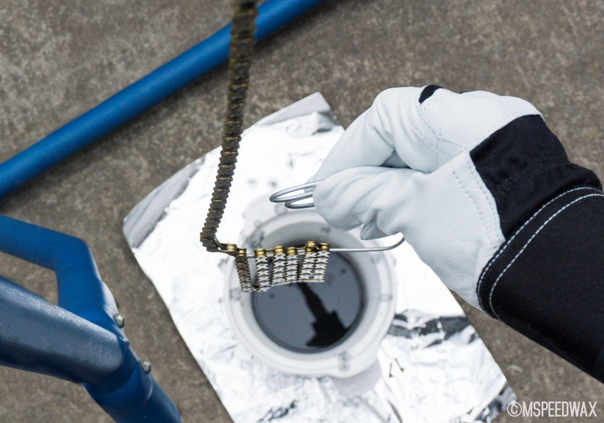

HOW TO CLEAN MY CHAIN FOR WAXING

Cleaning a chain to prep for waxing (or even most good drip lubes) is best thought of as a two part process. Part one is cleaning the drip lube / factory grease off, the second part is ensuring there is no film left on chain from cleaning that would affect wax adherence / lube access to chain metal. The solvents we recommend here are a simple, relatively cheap, tested and proven way to clean and prep your chain. Some swear by cleaning chain with petrol / diesel/ degreasers etc but these in themselves are problematic in how much residue / film of themselves they leave behind - making it more laborious to clean off what you just used to clean chain…. If you follow the below, it is easy, cheap and always works perfectly.

**NOTE – Cleaning of new chains or existing chains for waxing only needs to be done prior to first wax. After first wax no further cleaning is required, simply pop chain off bike – stick on top of wax in pot, turn pot on, come back sometime later when melted to give a bit of a swishing, hang to set. That’s it. Cleaning days are basically over. You get very quick at re waxing in no time, and with no cleaning time / solvent costs, and usually at least double to triple the lifespan extension on chain and drive train parts – immersive waxing is both a TIME SAVER vs drip lubes as well as big $$ saver in drive train running costs. And you are running day in day out very low friction. And you have an always great looking drive train. Win, win, win, win. Hence why it is ZFC’s top recommended product.

For normal road riding with Mspeedwax there is so little contamination picked that it is not economically viable in either time or $ on cleaning products to try to attain greater extension of chain / wax lifespan by following any type of cleaning process prior to re waxing. Just pop off bike and into wax pot.

Post solid wet rides or dirty cx / mtb rides, a quick bit of maintenance can be good to minimise the amount of contamination imported into wax pot. But, good news is – it is the easiest chain clean ever.

Simply swish chain in boiling water in an open container using same swisher tool you use for re waxing (do not shake in a closed container, this will release steam pressure, blow lid off container and spray your face with scalding water and steam which isn’t optimal). Whilst MSW is solid and the most contamination resistant lubricant there is, water provides the medium that transports contamination deep inside the chain, some of which will be forcibly pressed into the solid wax. A good swishing in boiling water will melt a great amount of the more contaminated wax off chain, keeping the wax in your wax pot cleaner for longer. Thoroughly dry chain with hair dryer / air compressor / heat gun, pop chain into pot, turn pot on. You will feel chain is silky smooth when drying after nothing more than a hot water rinse that took you all of 5 mins to do and not a solvent in sight. If you have ever popped drip lube chain off and felt chain after first round of solvent clean, you get a horrible gritty crunchy feeling showing just how much abrasive stuff is inside wearing through your chain and adding lots of friction. The feeling with a Mspeedwax chain and just boiling water rinses after tough conditions rides is all the proof you need just how much of a different league immersive waxing with the top wax is vs drip lubes.

*It is not worth doing boiling water rinse as standard practice for normal dry road riding – it will cost you more in electricity to boil the kettle than you will attain in extending lifespan of chain / wax. There is simply so little contamination is gathered in normal road riding, just pop off bike and into wax pot.

Cleaning New chains with factory grease

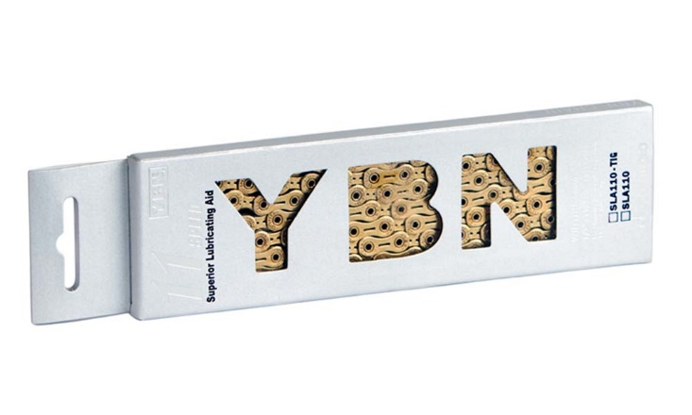
Factory grease is meant for packing, it IS NOT a good lubricant. Never ever put a new chain on and then race / do a big event. You are adding a stack of extra friction. Some factory grease is up to 5w higher friction vs just a decent drip lube (sram). It is also horrendous for grabbing and holding contamination. So no matter if waxing or using a good drip lube, clean off factory grease – it is meant for packing and if stock may sit on a or warehouse for a decade or so – it is not for riding.

Until ridden which oxidises factory grease, it is also pretty stubborn and doesn’t dissolve off readily – it takes a bit longer to properly dissolve. So just using a small plastic container with lid;

- Overnight soak in mineral turps. Agitate, pour out, wipe chain and container, and give a second overnight soak (or at least a few hours) in fresh mineral turps.
- Agitate, pour out, wipe chain and container, and give a final third agitated flush with fresh mineral turps.
- **NOTE – Sram factory grease / glue can take up to 2 or 3 extra baths. Srams factory glue really is a pain**
- A thorough agitated shake in methylated spirits – 2mins. Methylated Spirits is almost pure alcohol and so ensures no film left behind.
- Pour out and give second agitated shake in methylated spirits for 2mins.
- Wipe dry
- Blow dry for 5mins with hair dryer.
- Now ready to wax. (note – turn wax on after chain cleaned to allow for more drying time as wax melts)

Cleaning Existing / Used chains

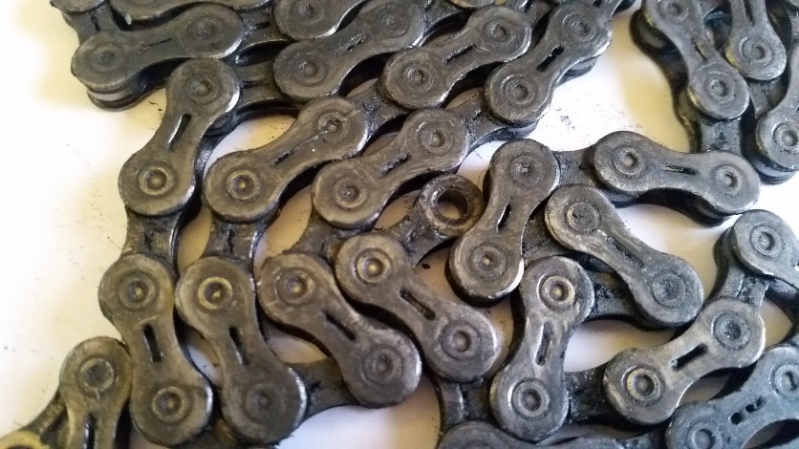

Everything is the same as above except – once factory grease will has been oxidised by riding it will dissolve off without needing overnight soaks. Using mineral turps simply agitate bath one after the other until the turps comes out as clear as it went in. The first will go instantly black, pour out, wipe chain and container, go again – it will go black, repeat, repeat, repeat etc.

On average it takes usually 7 to 12 agitated mineral turps baths with to get an existing chain clean, then move to 2 to 3 thorough agitated methylated spirits baths.

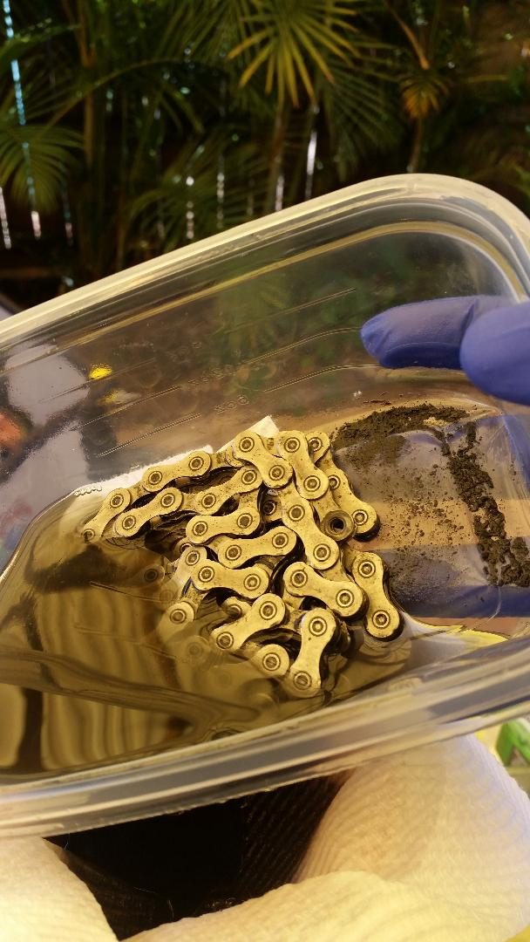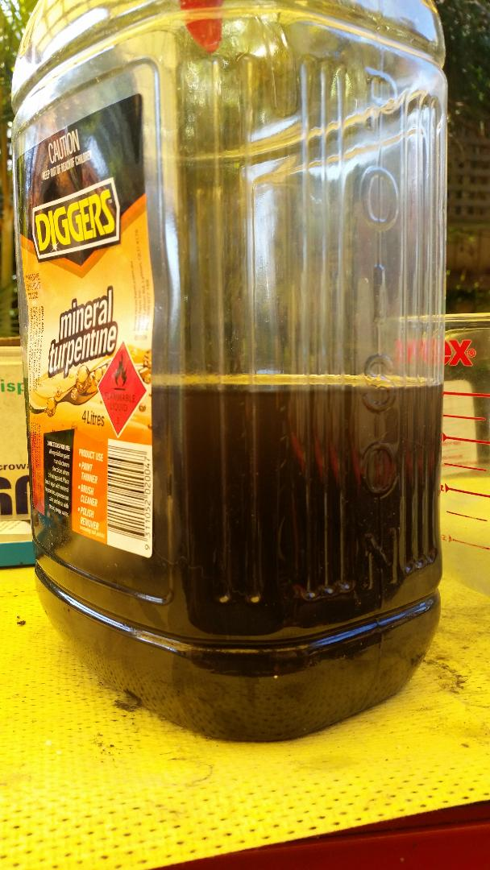

Wipe chain dry, blow chain dry hairdryer for 5 mins, now ready to wax. (note – turn wax on after chain cleaned to allow for more drying time as wax melts).

Because of the amount of product needed, as well as how quickly a chains special low friction coatings and other surface treatments are damaged using gritty drip lubes, you have to weigh up how old a chain you want to clean up. World Tour teams replace their chains every 500 to 1000km – largely due to the fact that on drip lubes the low friction coating will be abraded off by this time.

I usually only recommend cleaning a customer chain up to around 1500km or 0.15 wear mark old. Once a chains coatings are abraded off, there is a jump in friction and wear rate, so one has to weigh up is it worth spending the $ on the amount of solvent required to get a properly clean chain – it could be up to 3+ litres of mineral turps and then half a litre of methylated spirits on an already compromised chain – so cleaning a 50%+ worn chain for waxing is likely not worth it. Either stay the course and keep an eye on wear and switch next new chain, or get a new chain and switch and enjoy a whole new world of low friction, cleanliness and parts longevity now.

Ultrasonic Cleaning

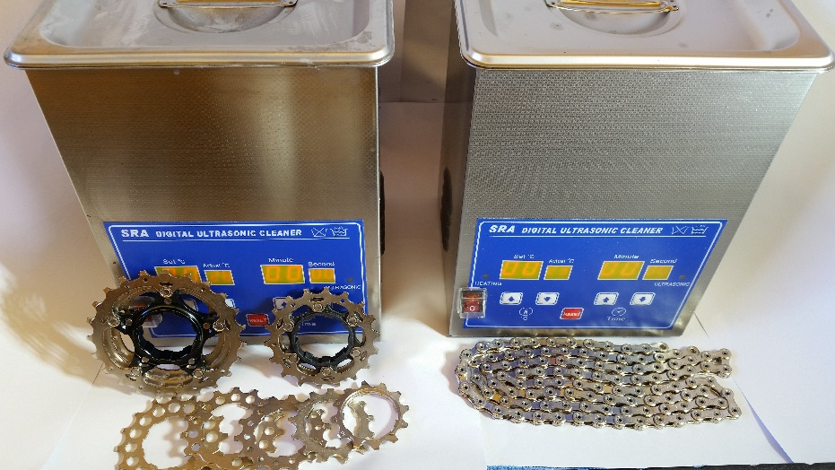

If you wish to ultrasonic clean your chain please refer to the Ultrasonic Cleaning and race chain guide prior - https://zerofrictioncycling.com.au/wp-content/uploads/2018/10/Ultrasonic-Clean-Race-Chains-Quick-guide-v3-converted.pdf

I get the odd customer contact re wax adherence issues from customers who have prepped chains at home and almost always it has been due to using an ultrasonic cleaner to prep. The perception is that a US clean is king and one’s work is done having completed doing that. This leads to the methylated spirits rinses being skipped, and the film left behind from the US clean prevents wax adherence and leads to a poor experience. This film can also contaminate wax in pot etc.

A US cleaner will not quickly dissolve factory grease – you still cannot skimp on that initial good soak.

For existing chains there is also not much point in using for the initial stages of cleaning for existing chains as there is so much contamination the solution will be black in 10 seconds. If you cleaning solution is black and dirty, obviously not much good cleaning is happening after that point. The ultrasonic is best when used as the final steps when chain is already very clean to get into tiny fissures / nooks and crannies that agitated container method will not reach.

And – must always, always finish with methylated spirits baths – not just whatever solution you used in Ultrasonic.

Getting a pre waxed chain

At ZFC one of the most popular services is cleaning chains / drive trains for waxing. Especially with a new chain purchase, having the chain already pre cleaned of factory grease and waxed takes the hard part out of switching, and at a similar cost as if you had to go out and buy mineral turps and methylated spirits yourself. You can can just skip straight to cleaning up your drive train then happy days re waxing. I am rather well practiced and set up for cleaning chains, I have ultrasonics and know how to use them, and so you can get a properly prepped chain at a small surcharge to cover product cost and prep time.

Also, about 99% of my solvent use is recycled via an alcohol distiller, and any remaining solvent that needs to be disposed of is done so via SA Hazardous Liquid Waste. Correct disposal of solvents is less likely with home cleaning.

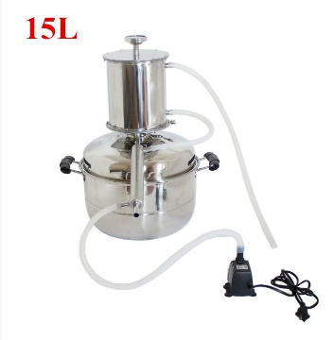

How to clean drive train for waxing?

Cleaning drive train is much simpler as you don’t need to worry about leaving a film behind / wax adherence to internals of chain etc – but you do want a clean drive train. Good news is it will be pretty much the last proper clean you will need to do!

You don’t want to put your beautiful clean wax chain on an oily dirty drivetrain – the wax will absorb some of that oily stuff, contaminate it, then it goes into wax pot etc – so just give it a good clean with your favourite drive train cleaner be it degreasers, mineral turps, morgan blue is great etc.

Main thing is don’t just clean side of cogs and chain rings – make sure clean between teeth, and make sure clean derailleur cages etc. If you have the tools and know how – removing cassette and jockey wheels for cleaning can make it easier.

So…. How to wax, Here we go…

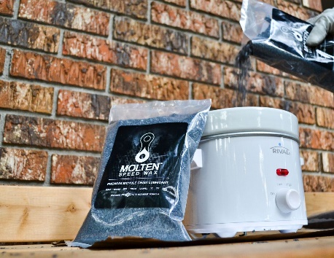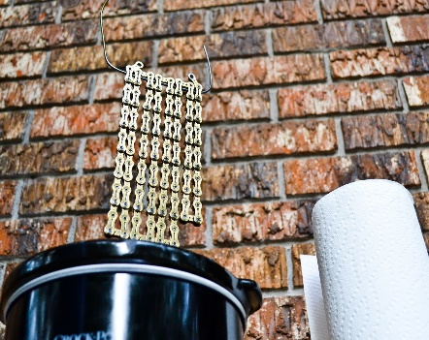
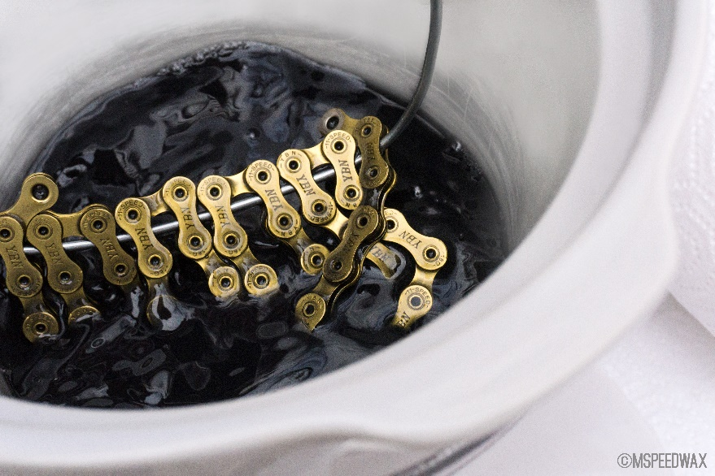

- Remove chain from bike by popping open master link and keep link somewhere safe (insert master link removal pliers as shown and squeeze pliers – master link will pop open, chain can then be easily removed). *Make sure you have in small chain ring and 11t cog otherwise spring tension from rear derailleur can make for an energetic chain opening!

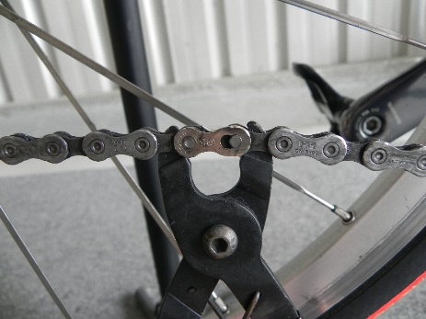

- Thread chain onto swisher tool (made easily from coat hanger) – basically a piece of wire bent into a u shape

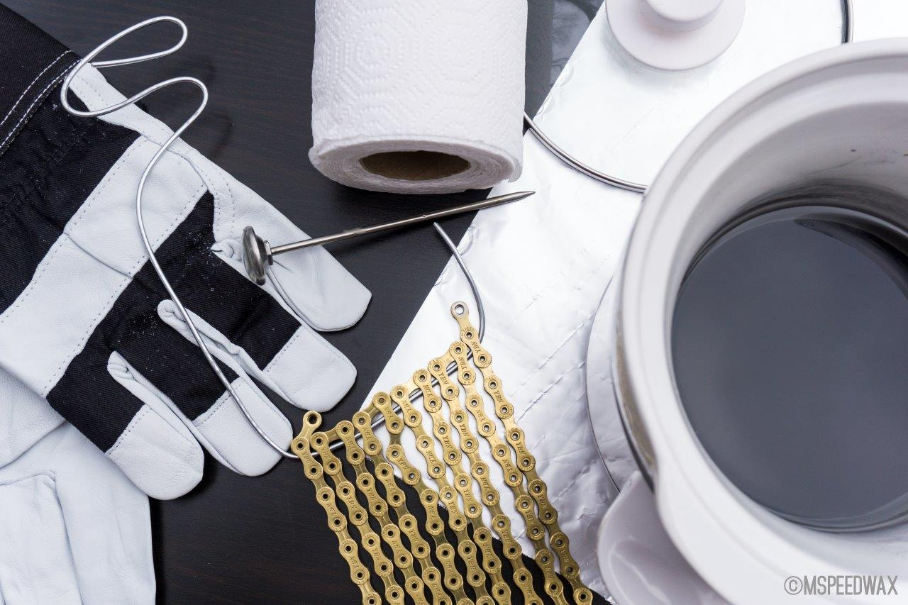

- If planning to hang chain off a nail / screw after waxing, thread a paperclip through hole of last link

- Turn slow cooker pot onto low setting, remove lid and place chain on top of wax in pot. (It is best to let chain melt into wax. As the wax melts the chain will heat up with it, and the wax on the chain melt into the pot as well. That way, when you come back, you can just start swishing it around. If you melt wax first and then place chain in later – leave in there for 5 mins so the chain can heat up fully as well)

- Come back in about an hour or whenever you like after an hour – ish

- By then wax should be all melted, and with it the chain has heated up very nicely too and the wax on the chain has melted into pot.

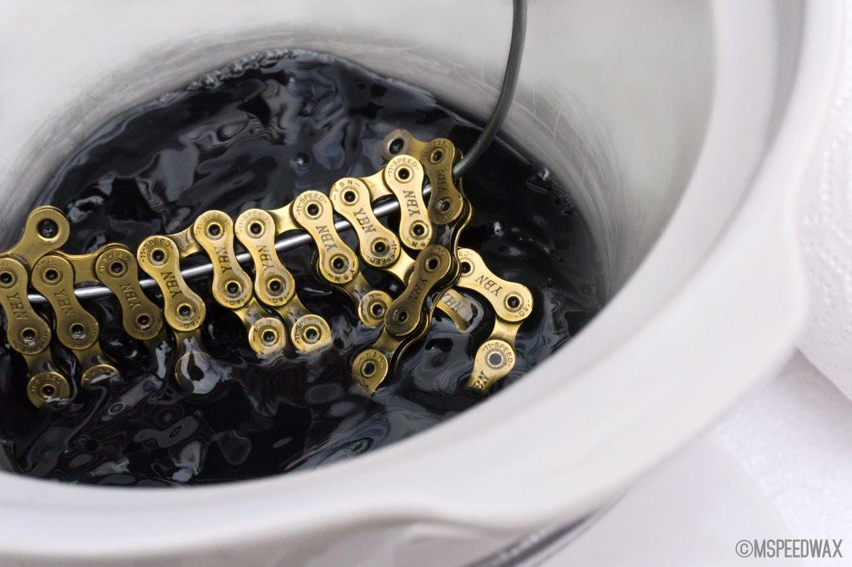

- Swish the chain around relatively vigorously in pot for about 20 – 30 seconds then lift out and hang for about 15 seconds above the pot to let wax drip off chain into pot
**Note – it is possible – especially if wax is quite hot and therefore chain quite hot – that the swishing will cause a roller on end of chain to come out of link. Check that the rollers are in place when remove chain, and if not find roller in wax pot and pop back in (wear rubber gloves or use magnet). It is rare this happens – but I have heard of it happening and had it once myself – threading a paper clip through the chain ends will prevent from ever happening.

- If using two pot system, repeat the swishing in pot 2. Two pot system has the advantage that any contaminants are flushed into pot 1, leaving pot 2 wax very clean. After approx. 30 waxes, pot 2 wax becomes pot 1, discard pot 1 wax (into a take away coffee cup works great), and fresh bag of wax into pot 1. Two pot system expect around 9000km per bag vs 6000km for single pot where recommend change wax after approx. 20 waxes x 300km ish vs 30 waxes for two pot system).

- Hang chain somewhere to dry. Some wax will drip off chain onto the ground, so if hanging over any marble and gold flecked tiles or expensive paving, place a matt over tiles (the wax can be cleaned off surface but depending on surface it can be a bit tenacious. It bonds well to most surfaces, part of why it is most excellent on chains).

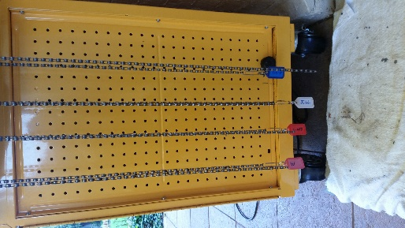

- When wax is dry / set – about 15 mins most days – it will be very stiff and solid.

You can re-install now, but usually I just hang my chains to dry and then allow 2 mins before next ride to re-install. You get very quick at it in no time.

- To re-install, you need to break the wax bond on each link. There are various methods of doing this, you can break each one by hand, I do mine of the handle of my big tool chest, you can do it standing over bike with chest on seat, wrap chain just around cassette and pull chain up towards you, bond on each link will be broken as it is pulled through cassette, or u can use a piece of dowel or plastic tubing – you will find an easy method that works for you. On warm days breaking wax bond is easy, if it set on cold day, it will be a bit harder.

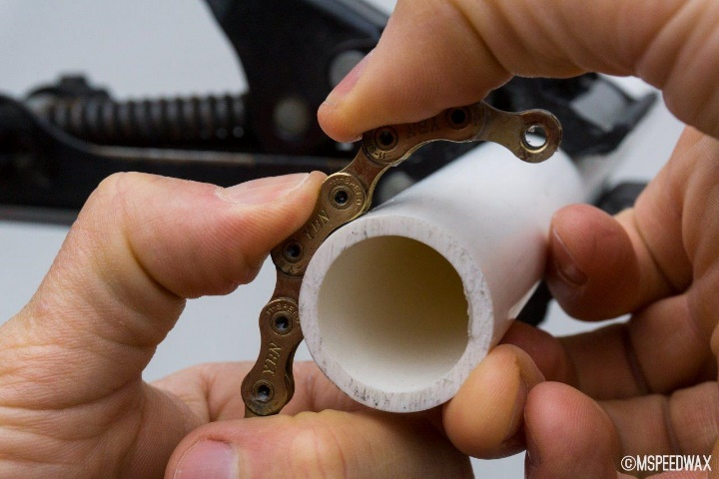

- Re-install chain on bike and reconnect master link. Simply push pins into wider part of link plate locking channel such that they will be able to be pulled back into the narrow part of the link plate locking channel. Pay close attention that the channels at end of pins are in correct place ON BOTH SIDES OF LINK such that when link is pulled in opposing direction they will slide back to lock into narrower part of link plate locking channel. It is possible to have just one side lock into a channel whilst other side misses locking into channel. This will lead to failure of the master link under pedalling load. It is simply reverse of step 1.

As my photography is terrible, I have pulled an image of the good ol interweb. This demonstrates what is happening nice and clearly. What it doesn’t show is that some force is required to pull pins into locking channels. Master link connect pliers make this easy, they simply do the reverse of release pliers. Release pliers squeeze link together so that pin pops out of wider part of channel, connect pliers force pins away from each other such that pins are pulled into locking channels.

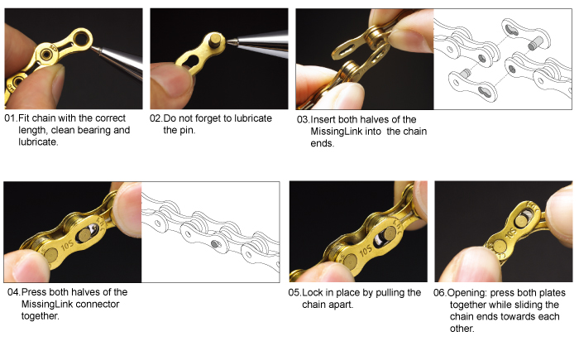
You do not have to purchase connect or release tools, you can squeeze links together with pliers, you can lock link into place by first setting pins in place ready to be pulled into channels, spin back wheel anti clockwise to move chain to top of drive train, the give pedal a sharp tap forwards to put tension on chain which will pull pins into locking channels. This method does increase risk of only one side of link engaging, so be sure to always check both sides of link before riding.

Note that YBN master links are re-usable (recommend 5 re uses per link then replace) and not directional.

- After you have re- installed chain, pedal the chain in small chain ring and in smallest cog for about 30 seconds, this will break the wax in a bit more and fling excess dried wax away that will simply brush off bike or anything else. The chain will initially feel very stiff as the solid wax starts to be broken in, and it can be harder for rear derailleur to change gears until after a few minutes of riding.

- First ride on freshly waxed chain it is best to ride in small chain ring and small cogs for a few minutes (I aim for 5minutes). Small chain ring + small cogs articulate the links through full range of motion and will l ensure wax is nicely broken in and ready to rock your world with silky smooth & clean lubrication for hundreds of km’s.

- Being very thorough – If the chain is freshly waxed and the next ride is a race, MSW
recommend at least 20mins of riding to ensure wax is properly broken in and surface polished. 30-45mins is the real butter zone where a wax treatment is hitting its absolute lowest friction. But bear in mind, if you don’t manage to get that run in time before a race, even after a couple of minutes of riding it is still going to be way lower friction than any oiled chain, and it will just keep getting better as the race goes on.

- Speaking of racing part 1 – If you use Molten Speed Wax Race Powder which reduces friction a further approx. 6% - the chain needs to be run in for at least 20mins to create enough space between the wax for the powder to penetrate. Even better if you have the time is the run the chain for another 10-20mins after first powder application and then re-apply powder. To apply just brush on with small brush, use a little rectangular container or tray underneath chain to catch excess powder, and wear gloves as it is quite staining. Apply to top and bottom of chain.

- Speaking of Racing part 2 – Consider a dedicated race chain. For those who race it is simply a very smart way to go. You are always going to need another chain sooner or later (sooner with drip lubes, later with waxing). So simply pre buying another chain to be a dedicated race chain doesn’t really cost any more at all. Then when training chain hits 0.5% wear – race chain moves over to become training chain, buy new chain to become dedicated race chain. Racing on the same chain you hammer away at in training is not as clever as having a chain kept as mint as possible for races. As a chain begins to wear, its efficiency losses increase, and also the first coating to be abraded away is a chains low friction coating. Dedicated race and training chain = very smart and one of the most cost effective ways to minimise friction losses from your hardest working mechanical component.

Click here for WAXING FAQ guide!

